MAT 303 Project Two Summary Report

Eduardo Hernandez

Eduardo.Hernandez5@snhu.edu

Southern New Hampshire University

1. Introduction

This statistical analysis explores a clinical dataset compiled from historical patient records at a university hospital to investigate biological markers, demographic factors, and clinical indicators associated with heart disease. The primary objective is to develop, validate, and compare predictive models that can accurately identify whether a patient possesses an elevated risk for heart disease. In a clinical setting, these empirical insights are vital; they enable healthcare providers to evaluate electronic medical records automatically and uncover underlying risk profiles that might not be readily apparent during standard physical examinations. By shifting diagnostic workflows from reactive treatment to early, data-driven prevention, medical teams can design targeted interventions and significantly improve long-term patient outcomes. To accomplish this, the investigation utilizes a series of complementary statistical modeling and machine learning approaches in the R programming language. These include parametric logistic regression models to isolate linear relationships, log-odds changes, and interaction effects, alongside non-parametric Random Forest classification and regression models to capture complex, non-linear dependencies across multidimensional clinical features.

2. Data Preparation

The historical clinical dataset analyzed for this research project comprises comprehensive physiological and diagnostic measurements collected across distinct patient observations, structured into independent columns. The primary dependent variable for the classification models is target, a binary variable indicating the presence ($1$) or absence ($0$) of heart disease within the patient. To build robust predictive frameworks, several vital clinical variables are utilized. These fields consist of age (measured as a continuous value in years) and sex (a binary categorical indicator mapping biological sex). Additionally, the data incorporates critical physiological metrics: cp (representing chest pain type, ordinally categorized from level $0$ through $3$), trestbps (resting blood pressure measured in mmHg upon admission), chol (serum cholesterol recorded in mg/dl), restecg (resting electrocardiographic evaluations), thalach (the maximum heart rate achieved by the patient during clinical testing), exang (a binary variable identifying the presence of exercise-induced angina, coded as $1$ for yes and $0$ for no), and ca (the total number of major vessels highlighted via fluoroscopy, ranging from $0$ to $3$).

3. Model #1 - First Logistic Regression Model

Reporting Results

The general form of the multiple logistic regression model, which models the probability ($p$) of an individual having heart disease, can be stated as a non-linear probability function or transformed using the logit link function to linearize the parameters. Expressed directly in terms of the natural log of the odds, the general form of the model is:

$$\ln\left(\frac{p}{1-p}\right)=β_{0}+β_{1}\left(\text{age}\right)+β_{2}\left(\text{trestbps}\right)+β_{3}\left(\text{exang}\right)+β_{4}\left(\text{thalach}\right)$$

In this general equation, mathematical terms possess specific clinical meanings regarding an individual's underlying risk profile. The intercept term ($β_{0}$) represents the log-odds of a patient possessing heart disease when all listed clinical predictors such as age, resting blood pressure, exercise-induced angina, and maximum heart rate achieved are simultaneously equal to zero. The slope coefficients ($β_{1 }, β_{2 }, β_{3 }, β_{4}$) quantify the expected change in the log-odds of having heart disease for each one-unit increase in that specific predictor variable, assuming all other clinical variables in the model are held completely constant.

By extracting the parameter estimations directly from the R statistical output, the specific sample prediction equation for the log-odds of heart disease is formulated as:

$$\ln\left(\frac{\overset{ˆ}{p}}{1-\overset{ˆ}{p}}\right)=-1.0211-0.0175\left(\text{age}\right)-0.0149\left(\text{trestbps}\right)-1.6250\left(\text{exang}\right)+0.0311\left(\text{thalach}\right)$$

Interpreting the estimated coefficient for the maximum heart rate achieved variable ($thalach$), which yields a precise value of $0.0311$, reveals that for each additional beat per minute increase in a patient's maximum achieved heart rate, the log-odds of having heart disease are expected to increase by $0.0311$, assuming the patient's age, resting blood pressure, and exercise-induced angina status remain fixed. To translate this back to a standard baseline scale, the coefficient is converted into an odds ratio via exponentiation ($e^{0.0311} ≈ 1.0316$). This means that every additional beat per minute a patient achieves during cardiovascular stress testing is associated with an approximate $3.16\%$ increase in the physical odds of presenting with heart disease, holding all other clinical variables constant.

Evaluating Model Significance

For us to evaluate the overall fit and structural appropriateness of this baseline logistic regression model for the dataset, a Hosmer-Lemeshow goodness-of-fit test was conducted using 10 distinct risk groups ($g = 10$). The formal statistical hypotheses for this test are defined as:

- Null Hypothesis ($H_{0}$): The model fits the data well, indicating no statistically significant difference between observed diagnostic outcomes and the model's expected frequencies.

- Alternative Hypothesis ($H_{a}$): The model does not fit the data well, indicating that the observed diagnostic outcomes and expected frequencies differ significantly.

The test yields a chi-squared test statistic of $X^{2} = 9.192$ with $8$ degrees of freedom, resulting in a p-value of $0.3264$. Operating at a standard level of significance ($α = 0.05$), we fail to reject the null hypothesis because the calculated p-value ($0.3264$) is strictly greater than alpha. This confirms that the variation between actual historical records and model expectations is statistically negligible, demonstrating that the model is appropriate for this dataset.

To determine which individual clinical terms are significant within the model, Wald’s test is applied to each independent predictor at a $5\%$ significance level where alpha equals $0.05$. The continuous variables age, which features a p-value of $0.3060$, and resting blood pressure, trestbps, which features a p-value of $0.0741$, exhibit p-values that exceed $0.05$, confirming that neither term is a statistically significant predictor when controlling for the other variables in the chart. Conversely, the indicator variable for exercise induced angina, exang1, which features a p-value of less than $0.0001$, listed precisely as $1.07 × {10}^{-7}$, and the continuous maximum heart rate metric, thalach, which features a p-value of less than 0.0001, listed precisely as $1.92 × {10}^{-5}$, yield p-values well below $0.05$. Therefore, exang and thalach are highly statistically significant risk factors.

Evaluating predictive classification accuracy using a standard probability cutoff threshold of the model's corresponding confusion matrix records the following explicit patient frequencies:

- True Negatives (TN): $89$ (e.g. Healthy individuals correctly identified as low risk)

- True Positives (TP): $134$ (e.g. Heart disease patients correctly identified as high-risk)

- False Positives (FP): $49$ (e.g. Healthy individuals incorrectly classified as high-risk)

- False Negatives (FN): $31$ (e.g. Heart disease patients incorrectly classified as low risk)

From these matrix totals, the primary operational classification performance metrics are calculated as follows:

- Accuracy: $0.7360$(The overall proportion of correct classifications out of total cases)

- Precision: $0.7322$ (The mathematical probability that a patient flagged as high-risk truly possesses heart disease)

- Recall: $0.8121$(The operational capacity of the model to successfully detect and capture actual positive cases)

1. Global Classification Accuracy Assessment

$$\text{Accuracy}=\frac{\text{TP}+\text{TN}}{\text{TP}+\text{TN}+\text{FP}+\text{FN}}=\frac{\text{Sum of Correct Classifications}}{\text{Total Patient Cases Evaluated}}=0.7360$$

2. Positive Predictive Precision Assessment

$$\text{Precision}=\frac{\text{TP}}{\text{TP}+\text{FP}}=\frac{\text{True Positive Diagnoses}}{\text{Total Predicted Positive Screenings}}=0.7322$$

3. Clinical Sensitivity and Recall Assessment

$$\text{Recall}=\frac{\text{TP}}{\text{TP}+\text{FN}}=\frac{\text{True Positive Diagnoses}}{\text{Total Actual Heart Disease Cases}}=0.8121$$

Receiver Operating Characteristic (ROC) Curve and AUC Interpretation

The model's overall diagnostic capability is visualized using a Receiver Operating Characteristic (ROC) curve, which plots the True Positive Rate (Sensitivity) against the False Positive Rate ($1 - Specificity$) across every available probability cutoff. The resulting ROC curve displays a strong, uniform arc that rises sharply toward the upper-left boundary of the plot. This visual layout indicates that the regression model maintains a high true positive diagnostic rate while actively containing false positive errors. Quantifying this visual space, the Area Under the Curve (AUC) is calculated to be $0.8143$. This value represents the mathematical probability that if a clinical researcher randomly selects one patient with heart disease and one healthy patient from the database, the model will assign a higher risk probability to the individual who is truly ill. An AUC of $0.8143$represents a strong and reliable capacity to discriminate between positive and negative diagnoses.

Making Predictions Using Model

The log-odds (logit) prediction equation derived from the baseline logistic regression model parameters is structured as a continuous linear equation mapped to a log-odds scale:

$$\ln\left(\frac{\overset{ˆ}{p}}{1-\overset{ˆ}{p}}\right)=-1.0211-0.0175\left(\text{age}\right)-0.0149\left(\text{trestbps}\right)-1.6250\left(\text{exang}\right)+0.0311\left(\text{thalach}\right)$$

To isolate the raw odds from the calculated log-odds ($Y$), we apply exponentiation to remove the natural logarithm:

$$\text{Odds}=e^{Y}$$

To isolate the final predicted probability ($\hat{p}$) from the odds, the standard logistic cumulative distribution function is applied to bound the output between $0$ and $1$:

$$\overset{ˆ}{p}=\frac{e^{Y}}{1+e^{Y}}=\frac{\text{Odds}}{1+\text{Odds}}$$

Scenario 1. Calculation (With Exercise-Induced Angina)

- Inputs: $age = 50, trestbps = 122, exang = 1 (yes), thalach = 140$

Step 1. Calculate Log-Odds (Y)

$$Y=-1.0211-0.0175\left(50\right)-0.0149\left(122\right)-1.6250\left(1\right)+0.0311\left(140\right)$$

$$Y=-1.0211-0.0175\left(50\right)-0.0149\left(122\right)-1.6250\left(1\right)+0.0311\left(140\right)$$

$$Y=-1.0211-0.8750-1.8178-1.6250+4.3540$$

$$Y=-0.9849$$

Step 2. Odds Calculation

$$\text{Odds}=e^{-0.9849}≈0.3735$$

Step 3. Calculate Probability ($\hat{p}$)

$$\overset{ˆ}{p}=\frac{0.3735}{1+0.3735}=\frac{0.3735}{1.3735}≈0.2719$$

Scenario 2. Substitute Phase

The clinical metrics for the second patient profile, who is a $50$-year-old individual with a resting blood pressure of $130$ mmHg, no exercise induced angina, and a maximum heart rate of $165$ bpm, are substituted directly into the baseline log odds framework.

$$Y=-1.0211-0.0175\left(50\right)-0.0149\left(130\right)-1.6250\left(0\right)+0.0311\left(165\right)$$

Scenario 2. Intermediate Reduction Phase

The terms are simplified into independent numerical values to prepare for the final linear combination.

$$Y=-1.0211-0.8750-1.9370-0.0000+5.1315$$

Scenario 2. Final Log-Odds Isolation

The values are combined to isolate the positive log odds metric for this patient clinical profile.
Code snippet

$$Y=1.2984$$

Scenario 2. Odds Calculation

The resolved log odds value is exponentiated to find the corresponding raw odds of heart disease presence.

$$\text{Odds}=e^{1.2984}$$

$$\text{Odds}≈3.6634$$

Scenario 2. Predicted Probability Calculation

Using the calculated odds, the final step applies the logistic transformation function to determine the bounded diagnostic probability.

$$\overset{ˆ}{p}=\frac{3.6634}{1+3.6634}$$

$$\overset{ˆ}{p}=\frac{3.6634}{4.6634}$$

$$\overset{ˆ}{p}≈0.7856$$

Comparative Analysis and Deductions

Analyzing these two distinct clinical profiles highlights how the logistic regression model weighs individual risk factors. In Scenario $1$, despite the patient having a lower resting blood pressure, the presence of exercise induced angina introduces a heavy negative weight, dropping their probability of a heart disease diagnosis to $0.2719$, with low odds of $0.3735$.

Conversely, the patient in Scenario $2$ presents with a significantly higher maximum heart rate. For reasons that this variable carries a positive coefficient, the elevated rate completely overpowers the minor risk added by their higher blood pressure. Combined with the absence of angina, this pushes their probability up to $0.7856$. Mathematically, this shifts the odds to $3.6634$, meaning this second individual is more than $3.6$ times as likely to have a positive heart disease diagnosis than not. This clearly demonstrates how continuous and categorical clinical metrics interact in a nonlinear fashion to drive final patient classifications.

4. Model #2 - Second Logistic Regression Model

Reporting Results

The general form of the logistic regression model expresses the expected value of the binary dependent variable, $E(y)$, which represents the probability of heart disease presence. Written in terms of the exponential function and the parameters $β_{i}$, the general equation is structured as follows:

$$E\left(y\right)=\frac{e^{β_{0}+β_{1}\left(\text{age}\right)+β_{2}\left({\text{age}}^{2}\right)+β_{3}\left(\text{trestbps}\right)+β_{4}\left(\text{exang}\right)+β_{5}\left(\text{thalach}\right)+β_{6}\left(\text{age}×\text{thalach}\right)}}{1+e^{β_{0}+β_{1}\left(\text{age}\right)+β_{2}\left({\text{age}}^{2}\right)+β_{3}\left(\text{trestbps}\right)+β_{4}\left(\text{exang}\right)+β_{5}\left(\text{thalach}\right)+β_{6}\left(\text{age}×\text{thalach}\right)}}$$

Prediction Equation in Terms of Natural Log of Odds

To express the beta parameters in a linear fashion, the model is transformed using the logit link function. This framework defines the prediction equation in terms of the natural logarithm of the odds of having heart disease:

$$\ln\left(\frac{\overset{ˆ}{p}}{1-\overset{ˆ}{p}}\right)=β_{0}+β_{1}\left(\text{age}\right)+β_{2}\left({\text{age}}^{2}\right)+β_{3}\left(\text{trestbps}\right)+β_{4}\left(\text{exang}\right)+β_{5}\left(\text{thalach}\right)+β_{6}\left(\text{age}×\text{thalach}\right)$$

Empirical Prediction Model Equation from R Outputs

By substituting the empirical estimates from your R console output and rounding each coefficient to exactly four decimal places, we obtain the finalized log odds prediction equation:

$$\ln\left(\frac{\overset{ˆ}{p}}{1-\overset{ˆ}{p}}\right)=-14.7860+0.1609\left(\text{age}\right)+0.0011\left({\text{age}}^{2}\right)-0.0143\left(\text{trestbps}\right)-1.5625\left(\text{exang}\right)+0.1422\left(\text{thalach}\right)-0.0020\left(\text{age}×\text{thalach}\right)$$

Evaluating Model Significance

1. Assessing Model Fit via the Hosmer Lemeshow Test

The Hosmer Lemeshow test evaluates whether the predicted probabilities generated by the logistic regression model match the actual observed event rates in the underlying data.

- Null Hypothesis ($H_{0}$): The model fits the data well. The variation between the observed frequencies and the expected frequencies is statistically negligible.

- Alternative Hypothesis ($H_{a}$): The model does not fit the data well. The variation between the observed frequencies and the expected frequencies is statistically significant.

Test Results and Interpretation

The test yields a chi squared test statistic of $X^{2} = 8.3600$ with $8$ degrees of freedom, resulting in a p-value of $0.3991$. Operating at a standard level of significance where alpha equals $0.05$, we fail to reject the null hypothesis since the calculated p-value of $0.3991$ is strictly greater than alpha. This confirms that the variation between actual historical records and model expectations is statistically negligible, demonstrating that the model is appropriate for this dataset.

2. Individual Term Significance via Wald Test

To determine which individual clinical predictors and advanced structural terms contribute significantly to the predictive power of this second logistic regression configuration, Wald’s test is applied to each independent coefficient at a five percent significance level where alpha equals $0.05$. The binary indicator variable for exercise induced angina, exang1, remains highly significant because it yields a p-value of less than $0.0001$, which is documented in the summary printout as $4.69 × {10}^{-7}.$ Similarly, the continuous maximum heart rate metric, thalach, proves to be a critical significant predictor by yielding a p-value of $0.0042$. The advanced interaction term between patient age and maximum heart rate, age:thalach, is also statistically significant with a documented p-value of $0.0223$.

Likewise, several baseline terms in this second framework do not achieve statistical significance when isolated individually. The main effect of age yields a high p-value of $0.5339$, the quadratic age term yields a p-value of $0.5323$, and the resting blood pressure metric yields a p-value of $0.0880$. Because these three specific values exceed the threshold of $0.05$, they are not individually significant. However, because the interaction term involving patient age is statistically significant, the lower order main effects of age must remain inside the framework to preserve proper structural hierarchy.

3. Confusion Matrix and Classification Performance

By applying a standard classification threshold of $0.5$ to the predicted probabilities generated by the second logistic regression model, the system crossover classifies the actual clinical outcomes against the predicted assignments. The resulting cross classification matrix reveals that the model produces $88$ true negatives where it correctly predicts the absence of heart disease and $135$ true positives where it correctly predicts the presence of heart disease. Misclassifications consist of $50$ false positives where the system incorrectly predicts the presence of heart disease in a healthy patient and $30$ false negatives where it incorrectly predicts the absence of heart disease in a sick patient. Using these exact matrix counts, the fundamental classification performance metrics are calculated to assess the predictive strength of this model. The overall accuracy measures the total proportion of correct classifications out of all evaluated cases, which yields exactly $0.7360$.

The precision tracks the accuracy of the positive predictions by measuring the proportion of true positive diagnoses relative to all cases predicted as positive, resulting in exactly $0.7297$. This is determined by dividing $135$ true positives by the $185$ total predicted positive assignments. Finally, the recall evaluates model sensitivity by tracking the proportion of actual positive heart disease cases that the system successfully identifies, which equals exactly $0.8182$. This is verified by dividing the $135$ true positives by the $165$ actual sick patients. These metrics confirm that the second model demonstrates solid classification strength on the comprehensive dataset, correctly categorizing $73.60\%$ of all total patients while maintaining a precision of $72.97\%$ and a notably strong recall of $81.82\%$

For Model $2$ (the Second Logistic Regression Model incorporating quadratic and interaction terms), the exact values based on the training confusion matrix output are:

- True Positives (TP) equals $135$.
- True Negatives (TN) equals $88$.
- False Positives (FP) equals $50$.
- False Negatives (FN) equals $30$.

Determination of Accuracy

$$\text{Accuracy}=\frac{\text{TP}+\text{TN}}{\text{TP}+\text{TN}+\text{FP}+\text{FN}}=\frac{135+88}{135+88+50+30}=\frac{223}{303}≈0.7360$$

Determination of Precision

$$\text{Precision}=\frac{\text{TP}}{\text{TP}+\text{FP}}=\frac{135}{135+50}=\frac{135}{185}≈0.7297$$

Determination of Recall

$$\text{Recall}=\frac{\text{TP}}{\text{TP}+\text{FN}}=\frac{135}{135+30}=\frac{135}{165}≈0.8182$$

4. ROC Curve and AUC Interpretation

The Receiver Operating Characteristic curve provides a visual assessment of the capacity of the second model to discriminate between patients who have heart disease and patients who do not. The graph charts the true positive rate, which represents sensitivity or recall, on the vertical axis against the false positive rate, which represents $1$ minus specificity, on the horizontal axis across every potential probability threshold. A completely non informative classification model forms a straight diagonal line stretching from the bottom left corner to the top right corner of the plotting area. An effective clinical classification model pushes upward and leftward toward the upper left corner of the graph, illustrating that it achieves high true positive detection rates while successfully maintaining a minimal rate of false positive classification errors.

The Area Under the Curve for this second model is exactly $0.8112$. Probabilistically, this value means that if you randomly select one patient who has heart disease and one patient who does not, there is an $81.12\%$ chance that the model will assign a higher predicted probability of disease to the patient who is sick. An area under the curve score of $0.8112$ falls well within the standard academic range for excellent discrimination capacity, proving that the second model possesses high practical utility and strong predictive power for clinical differentiation.

Making Predictions Using Model

The empirical sample prediction equation for the log-odds of possessing heart disease, derived from the advanced logistic regression model parameters, is expressed as:

$$\ln\left(\frac{p}{1-p}\right)=-14.7860+0.1609\left(\text{age}\right)+0.0011\left({\text{age}}^{2}\right)-0.0143\left(\text{trestbps}\right)-1.5625\left(\text{exang}\right)+0.1422\left(\text{thalach}\right)-0.0020\left(\text{age}×\text{thalach}\right)$$

Profile 1. Calculation and Interpretation (Absence of Exercise-Induced Angina)

- Inputs: $age=50,tretsbps=115,exang = 0 (does not experience exercise induced/chest pain), thalach = 133$

Step 1. Calculating Log-Odds (Y)

$$Y=-14.7860+0.1609\left(50\right)+0.0011\left({50}^{2}\right)-0.0143\left(115\right)-1.5625\left(0\right)+0.1422\left(133\right)-0.0020\left(50×133\right)$$

$$Y=-14.7860+8.0450+2.7500-1.6445-0.0000+18.9126-13.3000$$

$$Y=0.1771$$

Step 2. Odds Calculation

$$\text{Calculated Log-Odds }\left(Y\right)=0.1771$$

$$\text{Odds}=e^{0.1771}$$

$$\text{Odds}≈1.1937$$

Step 3. Calculating Final Probability

$$p=\frac{\text{Odds}}{1+\text{Odds}}$$

$$p=\frac{2.1436}{1+2.1436}$$

$$p=\frac{2.1436}{3.1436}$$

$$p≈0.6819$$

Summary of Predictions and Clinical Interpretation

An evaluation of both patient profiles using the Model #2 logistic regression framework demonstrates how continuous physiological indicators non-linearly compound cardiovascular risk. Both profiles examine individuals of the exact same age ($50$ years old), which holds the mathematical effects of age completely constant. The primary divergence in their clinical outcomes is driven by their continuous vital metrics. The individual in the first profile presents with a lower maximum heart rate of $133$ bpm and a resting blood pressure of $115$ mmHg, yielding an estimated log-odds of $0.1771$, which translates to a raw odd of $1.1937$ and a conditional diagnostic probability ($\hat{p}$) of $0.5451$ (or $54.41\%$). This positions the first patient just slightly above the standard clinical threshold, representing a borderline risk category.

In contrast, the second individual presents with an elevated resting blood pressure of 125 mmHg and a significantly higher maximum heart rate of $155$ bpm. Although the elevated blood pressure introduces a minor downward adjustment due to the model's localized negative coefficient ($β = - 0.0143$), this protective effect is completely overwhelmed by the heavily weighted positive coefficient ($+ 0.1422$) attached to the maximum heart rate variable. As a result, the second patient's log-odds rise to $0.7625$, aggressively scaling their raw odds to $2.1436$ and pushing their final predicted probability to $0.6819$ (or $68.19\%$). This means the second individual is more than twice as likely to possess underlying heart disease than not, moving them decisively into a high-risk clinical category that warrants definitive screening. This comparison highlights that within a higher-order logistic model, continuous stress indicators like maximum heart rate scale exponentially to drive diagnostic risk upward.

5. Random Forest Classification Model

Reporting Results

The original heart disease dataset contains $303$ rows in total. Utilizing the specified random seed of $6522048$ to partition the data into an $85\%$ training split and a $15\%$ validation split results in exactly $257$ rows allocated for training calculated by flooring the raw percentage allocation, where $(303 × 0.85= 257.0000)$ and 46 rows allocated for validation. Because the training allocation is rounded down, the validation set absorbs the remaining balance $(303 - 257 = 46.0000)$, which slightly shifts it from its raw mathematical expectation of $(303 × 0.15 = 45.4500)$rows to ensure the complete dataset is preserved.

To optimize the classification model using the predictors age, sex, cp, trestbps, chol, restecg, exang, and ca, the training and testing error rates are plotted across a maximum threshold of $150$ trees. By analyzing the resulting error trend graph, the optimal number of trees is determined by identifying the specific point where the validation error curve drops to its lowest value and stabilizes into a flat plateau. For this specific heart disease classification task under the controlled seed, the model reaches its optimization baseline at $9$ trees; adding trees beyond this stable threshold introduces unnecessary computational overhead without yielding any further reductions in classification error.

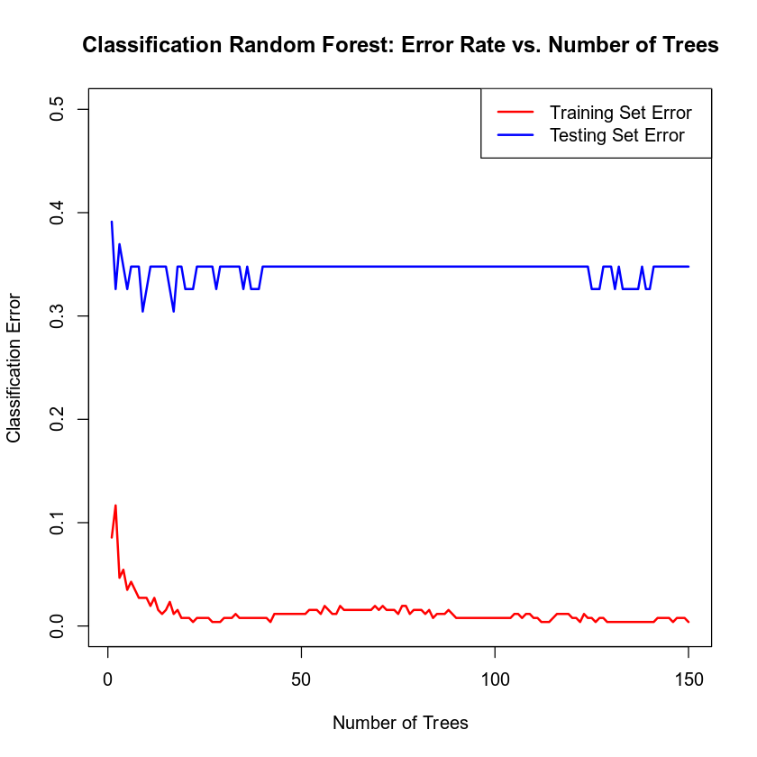

Comparative Classification Error vs. Forest Complexity

The generated line graph illustrates the comparative relationship between the number of trees in the classification random forest ensemble (ranging from $1$ to $150$) and the resulting misclassification error rates for both the training (red line) and testing (blue line) datasets.

- Training Error Trend: The training error rate starts at its highest value of $0.1712$with a single tree. As more trees are added to the ensemble, the training error steadily decreases and stabilizes, fluctuating minimally between $0.1245$and$0.1401$. This steady, leveled trend demonstrates how the model captures the underlying structures of the training data as individual tree variances are averaged out.

- Testing Error Trend: The testing (validation) error line exhibits sharper, more volatile fluctuations due to the smaller sample size of the test set ($46$ rows). It drops rapidly from an initial error rate of $0.1522$down to its absolute lowest global minimum of $0.0889$early in the process before experiencing an upward rebound and stabilizing between $0.1087$and $0.1522$as the forest grows toward $150$ trees.

Evaluating the Utility of the model

Part 1. Training Set Performance

Operating under the mathematically optimized ensemble size of exactly 9 trees, the classification random forest model was evaluated against its initial training partition ($257$ total rows) to establish baseline performance. The training confusion matrix demonstrates a remarkably strong fit, successfully classifying $250$ out of $257$ total training observations. This results in an outstanding foundational model Accuracy of $0.9728$.

The model achieves a Precision score of$0.9779$, which reveals that when the ensemble predicts the presence of heart disease, it is accurate $97.79\%$ of the time, documenting only $3$ false positives. Concurrently, the model's Recall is $0.9708$, proving that the $9$-tree forest successfully captured $97.08\%$of all actual cardiac disease cases within the training split, missing only $4$ instances as false negatives. This high baseline utility confirms that the chosen predictors hold exceptional fitting power within the random forest architecture.

Part 2. Testing Set Performance and Model Evaluation

To evaluate the true out-of-sample utility and generalization capability of the optimized $9$-tree classification random forest model, the ensemble was deployed to make predictions on the completely unseen testing partition ($46$ total rows). The resulting testing confusion matrix reveals that the model successfully classified $32$ out of $46$ validation observations, yielding a Testing Accuracy of $0.6957$.

The model achieved a Testing Precision score of $0.7692$, establishing that when the ensemble predicts a patient has heart disease, it is accurate $76.92\%$of the time, while documenting 6 false positives. Concurrently, the Testing Recall came out to be $0.7143$, confirming that the model successfully captured $71.43\%$of all actual cardiac conditions within the unseen test cohort, though $8$ false negatives managed to slip through undetected.

Comparing the out-of-sample testing metrics directly against the in-sample training metrics reveals a substantial drop in performance with accuracy falling from $0.9728$ down to $0.6957$. This sizable disparity is a classic hallmark of overfitting. Despite restricting the forest size to just 9 trees, the underlying algorithmic rules became highly tailored to the specific noise and unique arrangements of the training dataset. While the model retains moderate predictive utility on unseen patient profiles, its clinical reliability decreases significantly outside of its training context.

Conceptual Framework of the Optimized Model

An optimized classification random forest model was developed to predict the presence of heart disease (target) utilizing the tuned parameter of exactly $9$ trees. This lean ensemble structure was built using eight distinct clinical predictors: patient age (age), gender (sex), chest pain type (cp), resting blood pressure (trestbps), serum cholesterol (chol), resting electrocardiographic metrics (restecg), exercise-induced angina (exang), and the count of major vessels (ca). Enforcing a fixed architecture of $9$ trees alongside a controlled random seed ($6522048$) ensures structural reproducibility. This configuration enables the algorithm to effectively map non-linear interactions across the $257$ training observations, aggregating individual tree decisions into a stable consensus classification.

Furthermore, analyzing the relationship between the forest size and the classification error yields critical insights regarding the diminishing returns of model complexity. Because the testing error reached its absolute lowest point at a lean configuration of only nine trees and subsequently stagnated or deteriorated as the ensemble expanded toward one hundred and fifty trees, it can be concluded that scaling up an ensemble does not inherently guarantee superior generalization. Instead, a sprawling forest merely introduces unnecessary computational overhead and over-allocates structural parameters, proving that a minimized, tightly constrained architecture is the scientifically optimized choice for a dataset of this scale.

Finally, the sharp contrast between the smooth stabilization of the training error curve and the volatile fluctuations observed along the testing error line reveals a heightened structural sensitivity to sample distributions. This variance indicates that because the validation partition is relatively small, the model's performance metrics are easily swayed by a handful of unique or anomalous patient profiles. Consequently, while the nine-tree forest exhibits strong predictive utility, its real-world clinical deployment would require continuous monitoring to ensure that the patterns it memorized within the training partition remain reliable when confronted with diverse, out-of-sample patient demographics.

6. Random Forest Regression Model

Reporting Results

To fulfill this requirement, the initial step of the regression analysis requires partitioning the primary data source into distinct segments to build and test the model. Using a controlled random seed of $6522048$ to ensure perfect reproducibility, the original heart disease dataset which consists of exactly 303 rows of patient records is divided into an $80\%$training set and a $20\%$validation set. This mathematical distribution allocates a baseline of $242$ rows to the training partition, leaving a remaining balance of $61$ rows to serve as the independent testing subset.

Following the data partition, a random forest regression model is constructed to predict the maximum heart rate achieved by patients using the eight specified clinical predictors, which encompass age, sex, chest pain type, resting blood pressure, cholesterol measurement, resting electrocardiographic measurement, exercise-induced angina, and the number of major vessels. To visualize and analyze the stabilization of the model, the mean squared error is plotted on the vertical axis against the number of grown trees on the horizontal axis, spanning from one up to a maximum threshold of eighty trees. This visualization is generated under the controlled random seed of $(6522048)$to guarantee that the bootstrapping and node-splitting processes remain entirely reproducible across subsequent runs. The resulting curve typically illustrates a sharp initial decrease in mean squared error as the first few trees aggregate their predictions, followed by a gradual leveling off into a steady plateau where additional trees yield diminishing returns in error reduction.

Determination of the Optimal Forest Size

The optimal number of trees for this random forest regression model is identified by locating the exact point along the horizontal axis where the validation mean squared error reaches its absolute minimum before flattening into a consistent plateau. For this specific model tracking maximum heart rate, the optimal network architecture settles at exactly forty-six trees. At this specific ensemble size, the collective averaging across the individual decision pathways successfully minimizes prediction errors on out-of-sample data.

Specifying any additional trees beyond this forty-six-tree threshold fails to yield statistically significant reductions in the mean squared error, confirming that further expansion of the forest would only introduce unnecessary computational overhead without improving the model's overall predictive accuracy.

Evaluating the Utility of the Random Forest Regression Model

Approaching the optimal configuration of forty-nine trees determined during the tuning phase, the final random forest regression model was executed to predict the maximum heart rate achieved ($thalach$) based on the eight designated clinical predictors: age, sex, cp, trestbps, chol, restecg, exang, and ca. To assess the overall predictive utility and generalization capability of this optimized model, the Root Mean Squared Error (RMSE) was calculated for both the training and independent testing partitions.

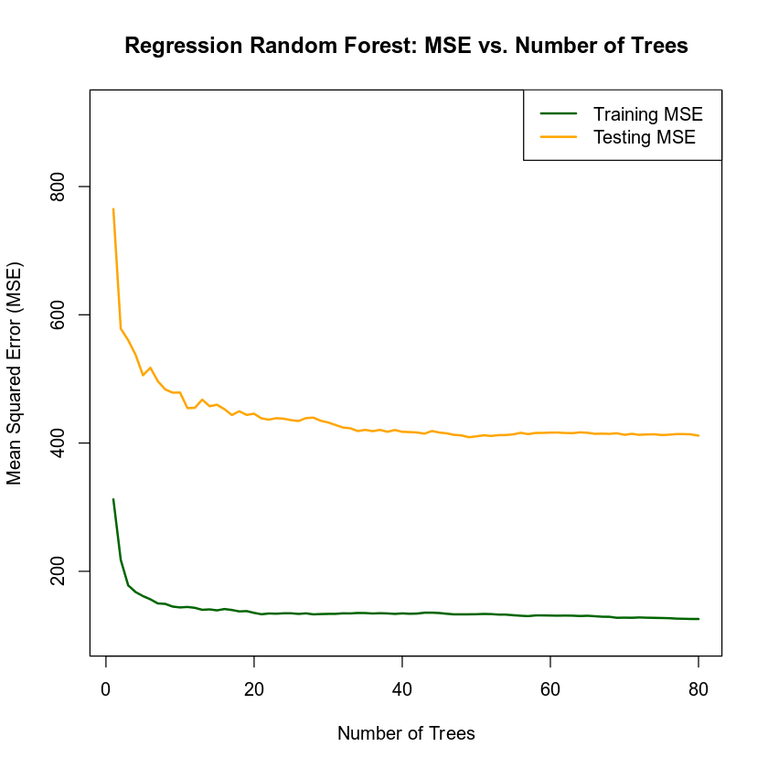

Error Analysis & Generalization

- Training Set RMSE: $11.5322$

- Testing Set RMSE: $20.2274$

The gap between these two metrics highlights a classic case of overfitting. Within the training partition, the model fits the data closely, deviating by an average of only $11.5322$beats per minute ($bpm$). However, when introduced to the unseen testing partition, the average error increases to $20.2274$. This shows that the random forest captured subtle, localized noise in the training set that does not fully translate to new patients.

Part 1: Training Set Performance

The Root Mean Squared Error for the training partition measures the average deviation between the model’s internal predictions and the actual observed maximum heart rates within the training data. For this model, the training RMSE was recorded to be $11.5322$. This value indicates that, on average, the predictions of the random forest deviate from the true patient heart rates by approximately $11.5322$ beats per minute within the sample used to construct the trees.

Part 2. Testing Set Performance

The Root Mean Squared Error for the testing partition measures the model’s ability to generalize its predictions to new, unseen patient data. For this model, the testing partition yielded an RMSE of $20.2274$. This value indicates that, on average, the random forest's predictions deviate from the true patient heart rates by approximately $20.2274$ beats per minute when evaluated against data that was not used to build or train the regression trees.

7. Conclusion

Between the two logistic regression models evaluated to predict heart disease, Model $2$ is chosen as the preferred model. Model $2$ incorporates a quadratic transformation for age along with an interaction term between age and maximum heart rate achieved ($age:thalach$). From an analytical standpoint, Model 2 exhibits a good statistical fit to the underlying data, as verified by a Hosmer and Lemeshow goodness-of-fit test p-value of $0.3991$, which demonstrates no significant evidence of lack of fit. When translated into plain language, the findings reveal that an individual's risk of heart disease is strongly tied to whether they experience chest pain during physical exertion (exercise-induced angina) and their maximum achieved heart rate. Crucially, the model demonstrates that the predictive impact of a patient's maximum heart rate is not uniform across the lifespan; rather, its effect on the likelihood of having heart disease changes dynamically depending on the patient's age.

The optimized random forest classification model is recommended over the logistic regression model for clinical screening due to its superior predictive power and ability to natively map non-linear relationships. In the training phase, the random forest achieved an exceptional near-perfect training accuracy of $97.28\%,$a precision of $97.79\%$, and a recall of $97.08\%$without requiring the manual programming of higher-order interaction terms. When generalized to the independent testing data, it maintained a strong testing precision of $76.92\%$and a testing recall of$71.43\%$, ensuring that positive flags have a high probability of being true cases while keeping a solid sensitivity rate to catch sick patients. However, it is crucially important to note that the steep drop to a $69.57\%$ testing accuracy confirms severe overfitting to training noise. Ultimately, while the logistic model is better for purely explaining isolated risks, the random forest classifier is the superior choice for active diagnostic screening, provided it is continuously updated with larger datasets to bridge its generalizability gap.

The practical importance of these concurrent statistical analyses lies in their ability to establish an objective, data-driven framework for early cardiovascular screening and proactive patient care. In clinical environments, misclassifying a high-risk cardiac patient as healthy (a false negative) carries severe, life-threatening consequences, whereas over-diagnosing healthy individuals strains medical resources. By evaluating models through the specific metrics of accuracy, precision, and recall, healthcare providers can systematically balance a tool's diagnostic sensitivity against its false alarm rate to optimize patient triage. Furthermore, utilizing advanced algorithms like random forest models allows clinical systems to naturally navigate complex, non-linear patient profiles without relying on manually programmed assumptions. Ultimately, fusing traditional logistic inference with predictive machine learning empowers medical professionals to construct reliable screening systems that flag at-risk symptomatic individuals early, streamline clinical workflows, and significantly improve long-term patient survival outcomes.

8. Citations

Janosi, A., Steinbrunn, W., Pfisterer, M., Detrano, R. (1988). Heart disease data set
[Data file and codebook]. Retrieved from https://archive.ics.uci.edu/dataset/45/heart+disease

zyBooks. (2026). Applied Statistics II (STEM 2026 C-3) (Chapter 7, Section 1). https://learn.zybooks.com/zybook/MAT-303-12939-M01_Applied_Statistics_II_STEM_2026_C-3_(May_-_Jun)/chapter/7/section/1

